

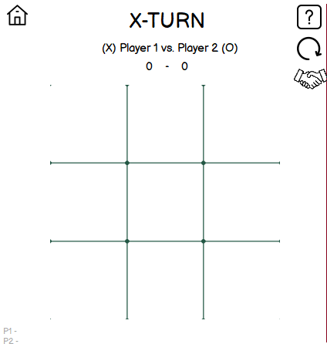The game is played on a 3x3 grid



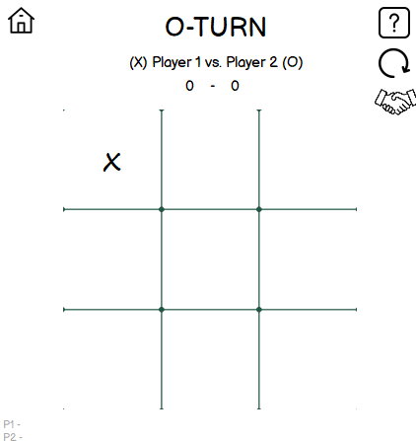Players will take turns, 1 box per turn.



The first player to get 3 consecutives X’s or O’s is the winner

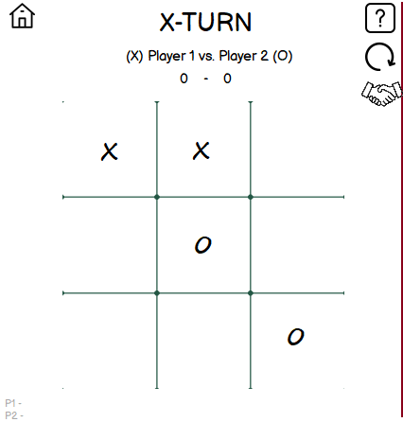



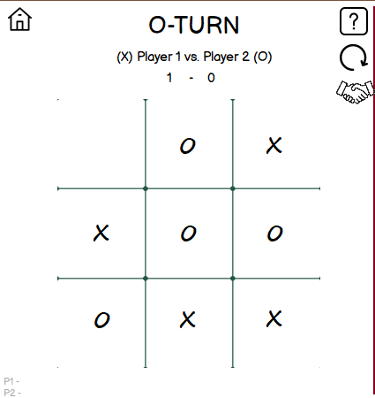Many rounds will may end up as a draw. Try to play Ultimate (more complex!)



The game is played on a 9x9 grid.

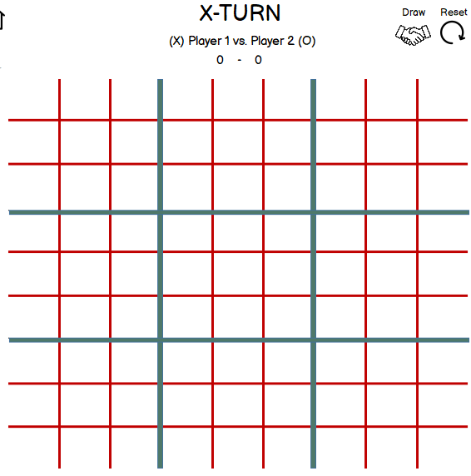



Take turns, 1 box per turn. The FIRST player to move can select freely.

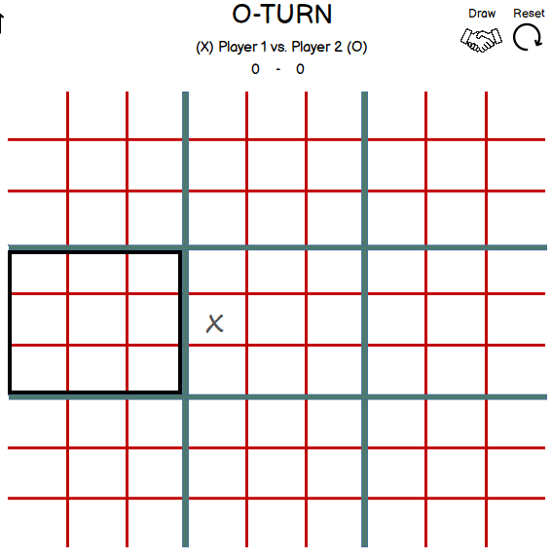



The next player will be restricted in terms of the previous selected box.



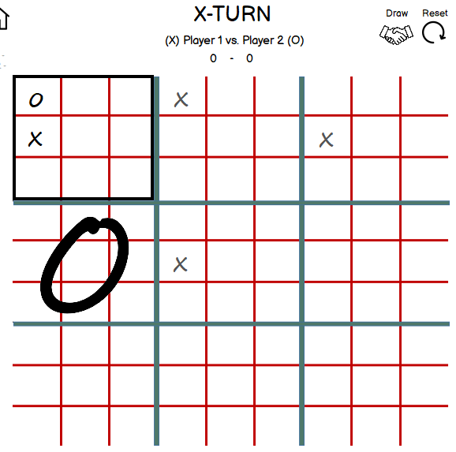Win inner box (3x3) with 3 consecutive X’s or O’s.



Sometimes, you will be selecting freely when last turn selects an occupied box.

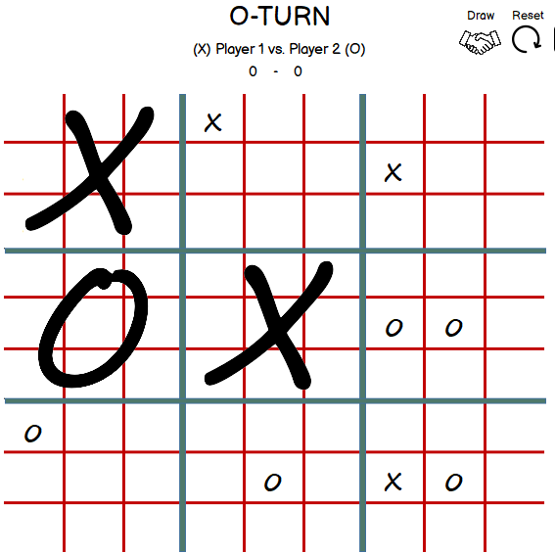



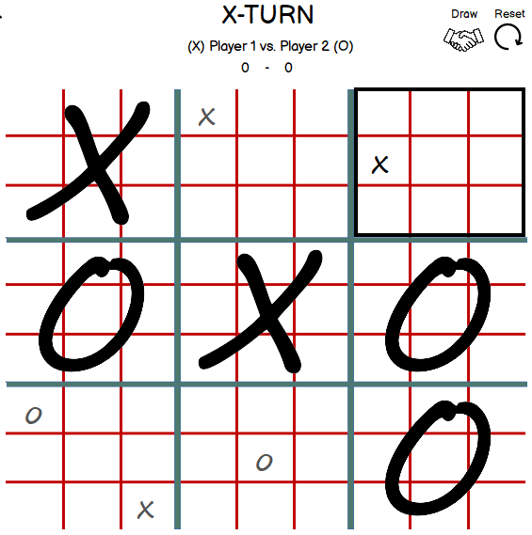Win ultimately by winning 3 consecutive big X’s or O’s.

Like playing Basic, a round may end up as a draw. To avoid that, win!

